|  |  |
| --- | --- |
| **ENGLISH** | **TRANSLATION** |
| HEADLINE: Wake-up call |  |
| AUTHOR Peter Garnry |  |
| INTRO The third quarter of 2015 will be remembered as the big wake-up call as global equities spun into their most violent period, measured by the first and second derivative of volatility, since the 2008 financial crisis. Developed-market equities are down 6.2% for the quarter but emerging-market stocks are brutally down 16.2%. |  |
| PULL QUOTE “Taking valuations and the recent drops in equities into consideration, we are betting on emerging markets to outperform all other markets over the coming year.” |  |
| In hindsight, it is clear that a correction was due as developed equity markets were becoming decoupled despite many warning signals from the stunning slowdown in China, recession in Brazil, Brent crude sliding another 25% – all leading indicators pointing down across the world and to higher USD rates on the horizon. |  |
| The world’s stock markets feel the sting  CHART 1 |  |
| It was likely a raft of Chinese macro data that suddenly triggered selling in developed-market equities, hauling them below certain threshold values and adding just enough volatility to kick start an unprecedented selloff across all major asset classes. |  |
| The downward pressure on stock prices was amplified, our research shows, by extensive deleveraging by risk parity funds, commodity trading advisor and managed funds. |  |
| Risk parity funds target annualised volatility of 10%. When their overweight in fixed-income assets collides with elevated volatility across all asset classes, the only way to target 10% volatility is to lower the leverage. |  |
| When that happens, chaos reigns for a while until order emerges again, and risk parity funds have by now covered around 40% of the 8.8% third-quarter drawdown. |  |
| **The Federal Reserve: how much, how fast?** |  |
| Higher USD rates are on the way for the global economy as the US needs higher interest rates. That is clear from data showing US job openings at their highest since 2000, unemployment down to 5.1%, signs of wage pressure in various industries, and a positive impulse to household spending from lower energy costs. |  |
| The big questions for equity investors are: how much and how fast the Federal Reserve will deliver tightening? The answers to both questions will mould a certain trajectory with implications for equity valuation and performance. |  |
| Research shows that equity markets are normally less volatile after a Fed rate hike, but then again we have never experienced a Fed rate rise from near 0%. In its latest economic projections, the Federal Open Market Committee forecasts the long-run Fed Funds Rate to be around 3.75%, compared with 5.25% in the previous expansion before the financial crisis. The mid-point forecast for the end of 2017 is 3%. |  |
| The expected “new normal” for the Fed Funds Rate will likely drive equity valuations to levels above their historical average. The reason is that, while the new normal reflects lower bond yields, lower inflation and lower economic growth, relatively will see investors demand more equities and fewer bonds in this low-yield environment. |  |
| Despite our view that US equities are a bit expensive relative to stocks the world over, their earnings yield is still impressively 5.8%, against 5.3% in BAA-rated corporate bonds and 2.2% in US 10-year Treasuries. |  |
| **Emerging markets a bargain** |  |
| The global rout in equities has turned certain regions and countries into bargain plays. German equities are now trading at 13.1x forward P/E. putting them at a 13% discount to UK and French stocks. This does not reflect the earnings power of German companies in relative or absolute terms. |  |
| Emerging-market equities trade at 11.6x forward P/E which is unusually low and, in our view, does not reflect long-run expected earnings growth. |  |
| Frontier markets are also trading at large discounts to emerging and developed-market equities which does not reflect their enormous long-run potential. |  |
| Given the current outlook for energy and mining, Canadian and Australian stocks look expensive. US equities are also on the dear side, while Japanese equities look cheap largely because of the weak yen. Taking valuations and the recent drops in equities into consideration, we are betting on emerging markets to outperform all other markets over the coming year. |  |
| Valuation measures for equities in various markets  CHART 2 |  |
| **Emerging markets will recover** |  |
| In classic Wall Street fashion, the plunge in emerging-market equities and especially China’s extreme volatility have caused many global investors to pull out, turning almost everyone into bears. |  |
| Many analyses conclude that the previous boom in emerging markets was only driven by the super-cycle in commodities. So, with commodities now at their lowest levels since 1999, the outlook for emerging markets is gloomy. |  |
| In our view, this underestimates the strong underlying forces in many emerging markets that are transforming themselves from pure export-driven and commodity producers into more balanced economies with more growth coming from domestic consumption as the middle class grows. The transition is already happening, and capital will flow back into emerging markets as soon as there is clarity over the trajectory of US rates. |  |
| **How to play equity markets** |  |
| The #SaxoStrats we send out to clients are not meant only to provide inspiration but to be part of a real portfolio approach. All ideas are driven by our views, but they also shape the current portfolio composition, and all positions are added to our account so we can track performance. All positions are set up with trailing stops and no targets. We never risk more than 1% of our equity on each trade. Because we have a trailing stop it is rare that we lose all 1%. |  |
| The portfolio currently has gross exposure of 221% and net exposure of 62%, which we believe is an appropriate level of risk going into Q4 as volatility is likely to stay higher than in the recent past. |  |
| We net short energy (Repsol) and mining (Randgold). For all other sectors we have a net exposure close to zero or positive. The portfolio is long Apple, BMW, Banco Santander, Biogen, Gilead Sciences, Novo Nordisk, GoPro, MSCI China and US homebuilders to name a few. The portfolio has 32 positions. It is also short 3D Systems, Alexion Pharmaceuticals, Citigroup, E.ON, France, Genmab and Novartis. |  |

CHART 1:

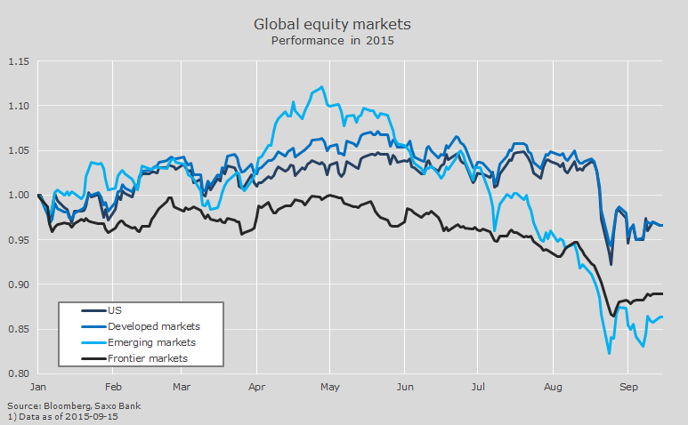

CHART 2:

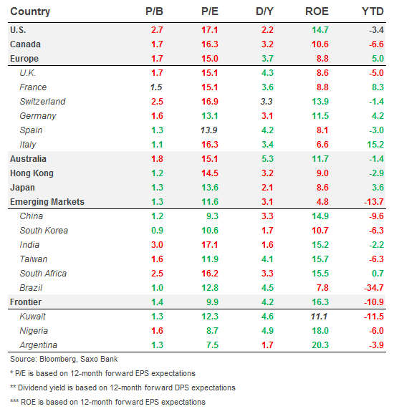

#SaxoStrats

As we believe China will make a forceful policy response, a change is coming to the commodity sector. US oil companies and global miners are already cutting back on supply, so if China can backstop the economy with more stimulus, demand will continue to grow and as a result should have a positive impulse on commodity prices. We are playing this scenario through a long position in Glencore that is currently being priced as if the global economy is heading towards a recession and commodity prices will never rebound. Read more in #SaxoStrats

<https://www.tradingfloor.com/posts/saxostrats-glencore-gloom-is-excessive-6273209>

Emerging market equities have been hit hard by the rapidly declining commodity prices with resource-heavy countries such as Brazil, Russia and South Africa taking the biggest beating. The latter country however has a bigger consumer-driven economy and has close proximity to the fast-growing sub-Sahara region. We are betting on the region to experience massive growth and one of the most interesting ways to play this theme is by going long insurance which is a basic need that correlates highly with economic growth. The South African insurer and investment bank Sanlam is currently expanding into the sub-Saharan region to grab this growth. With insurance penetration being very low, the near-term and long-term opportunities are enormous. Read more in #SaxoStrats

<https://www.tradingfloor.com/posts/saxostrats-insurance-as-a-fast-growing-industry-6234225>